|  |
| --- |
|  |

|  |
| --- |
|  |

|  |
| --- |
|  |

|  |
| --- |
|  |

|  |
| --- |
|  |

|  |
| --- |
|  |

|  |
| --- |
|  |

|  |
| --- |
|  |

|  |
| --- |
|  |

|  |
| --- |
|  |

|  |
| --- |
|  |

|  |
| --- |
|  |

|  |
| --- |
|  |

|  |
| --- |
|  |

|  |
| --- |
|  |

|  |
| --- |
|  |

|  |
| --- |
|  |

|  |
| --- |
|  |

|  |
| --- |
| **Tomato, 1** |

|  |
| --- |
|  |

|  |
| --- |
|  |

|  |
| --- |
|  |

|  |
| --- |
|  |

|  |
| --- |
|  |

**Tomato, 1**

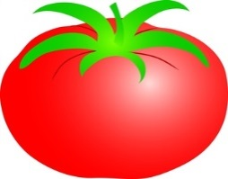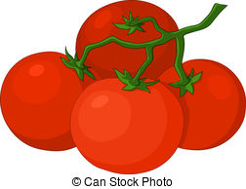

**Tomato, 1**

**Okra, 1**



**Okra, 1**



**Okra, 1**



**Okra, 1**



**Tomato, 1**



**Tomato, 1**

**Tomato, 1**



**Tomato, 1**

**Tomato, 1**

